Test Case: runTestMultipleTimes
Step 1 - Enter username and password and click to button Enter : Credentials Entered
Image file-name: QC_Testing-runTestMultipleTimes-nov. 24 2025, 07 32 09 p. m.

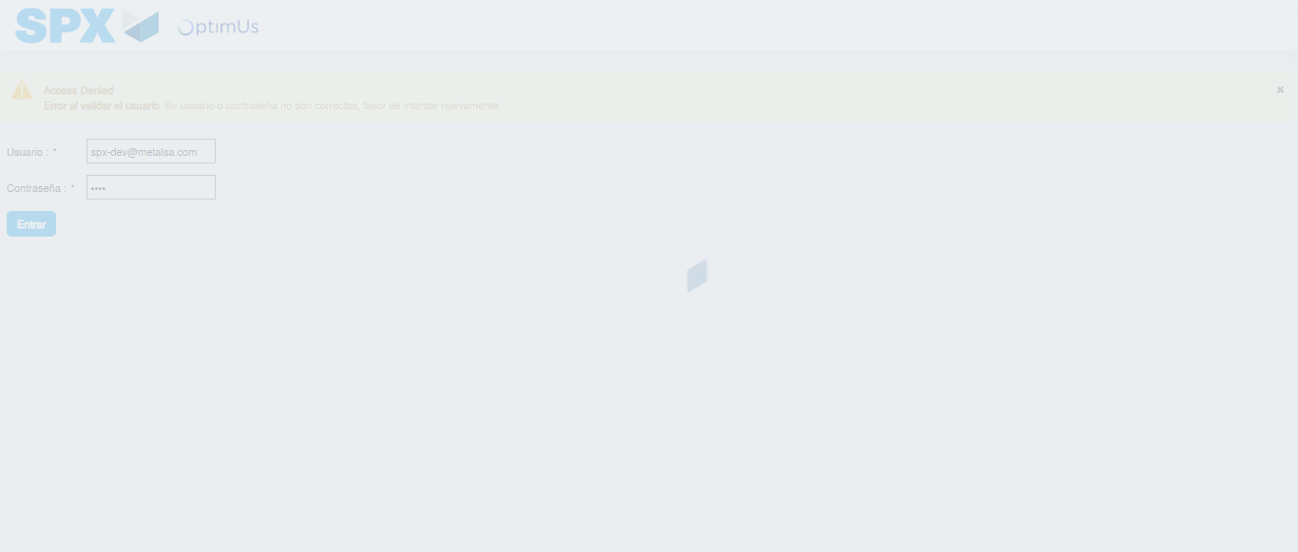Image file-name: QC_Testing-runTestMultipleTimes-nov. 24 2025, 07 32 10 p. m.

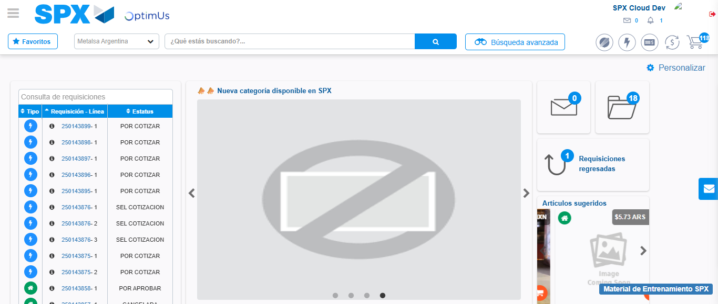Image file-name: QC_Testing-runTestMultipleTimes-nov. 24 2025, 07 33 46 p. m.

Step 2 - Select to UEN and Access to Spot Buy Requisitions : UEN Correctly selected and Correct access
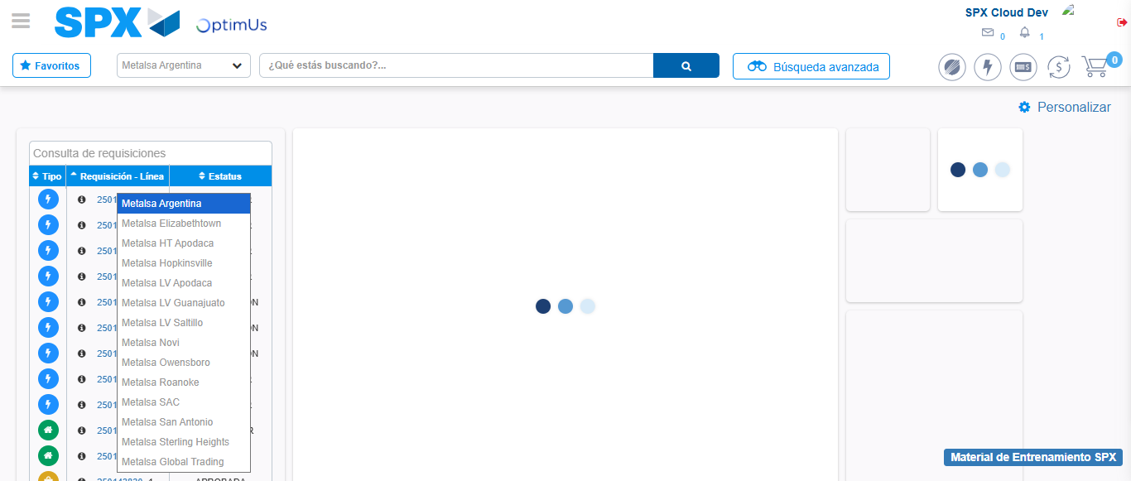Image file-name: QC_Testing-runTestMultipleTimes-nov. 24 2025, 07 32 13 p. m.

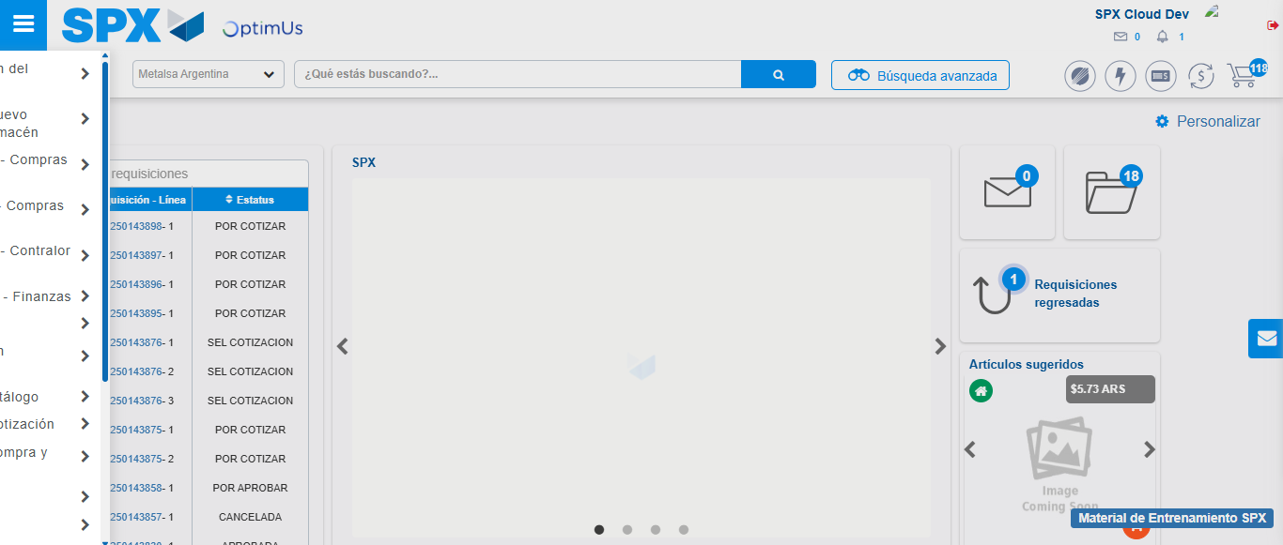Image file-name: QC_Testing-runTestMultipleTimes-nov. 24 2025, 07 32 14 p. m.

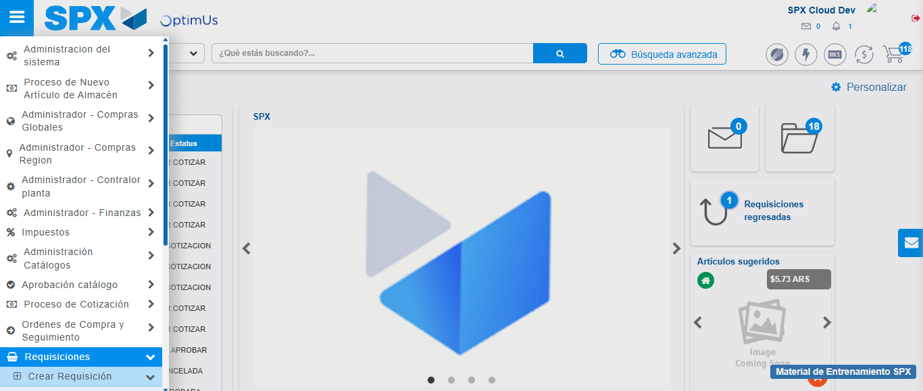Image file-name: QC_Testing-runTestMultipleTimes-nov. 24 2025, 07 32 15 p. m.

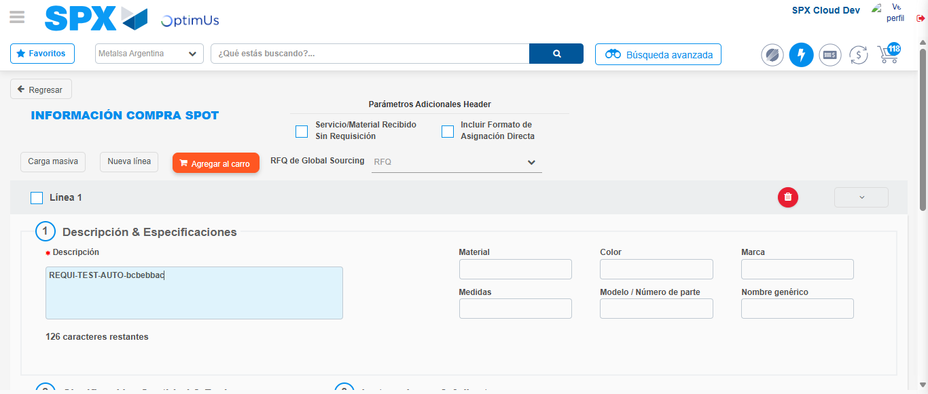Image file-name: QC_Testing-runTestMultipleTimes-nov. 24 2025, 07 32 19 p. m.

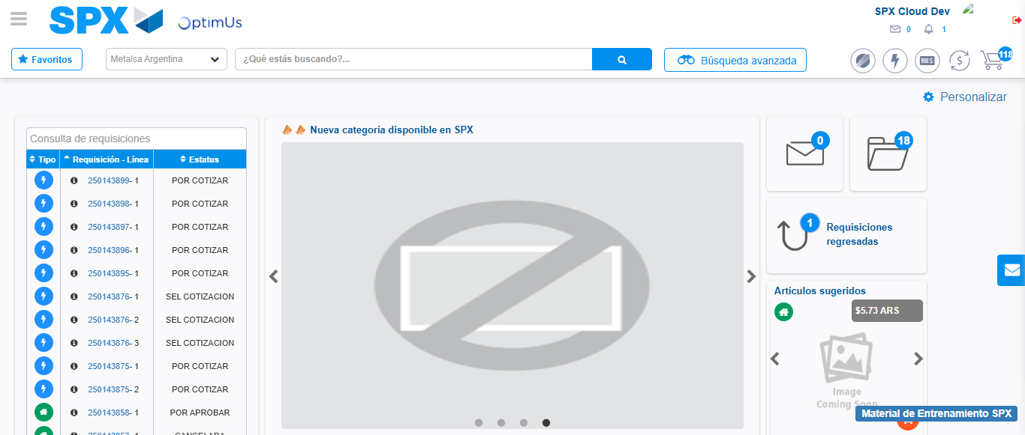Image file-name: QC_Testing-runTestMultipleTimes-nov. 24 2025, 07 33 47 p. m.

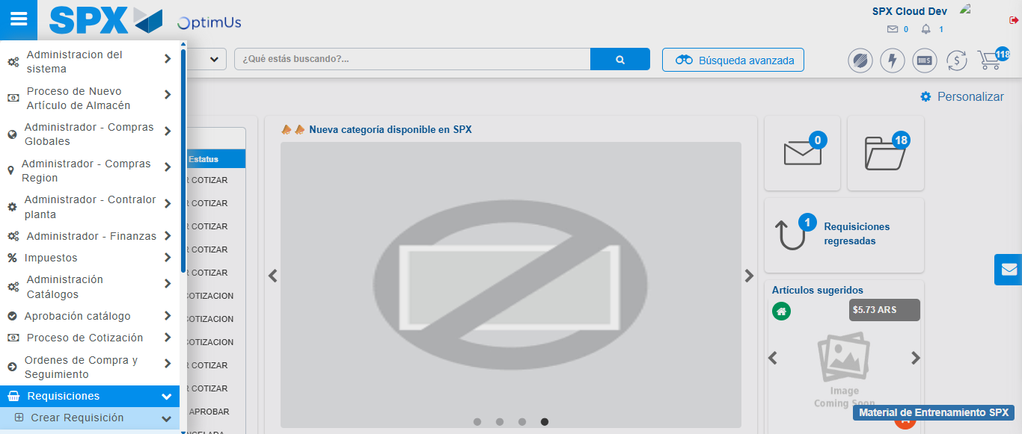Image file-name: QC_Testing-runTestMultipleTimes-nov. 24 2025, 07 33 48 p. m.

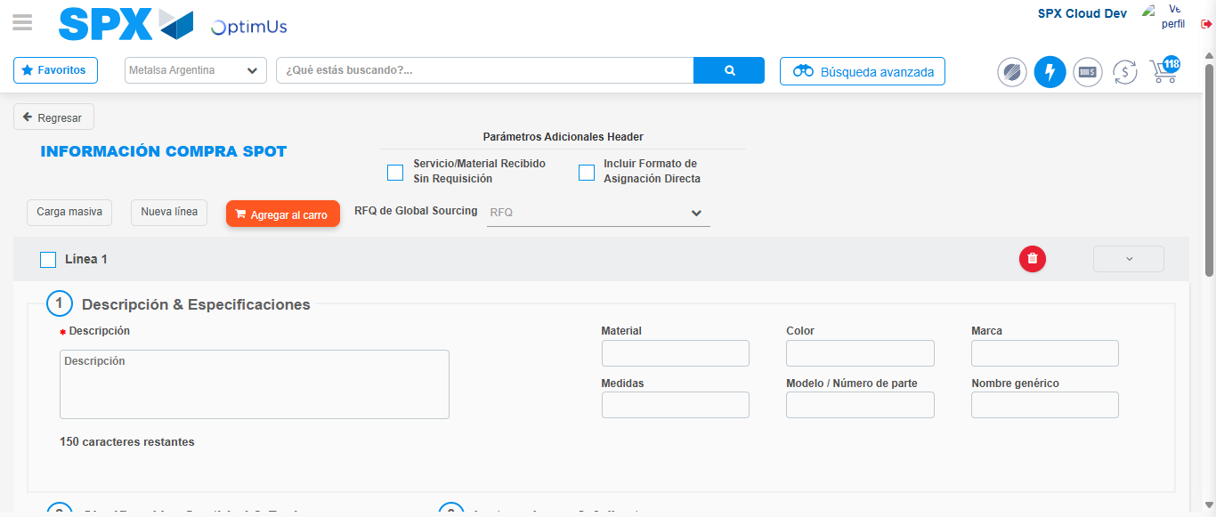Image file-name: QC_Testing-runTestMultipleTimes-nov. 24 2025, 07 33 51 p. m.

Step 3 - Data Capture Spot Buy Requisition : Data captured correctly
Image file-name: QC_Testing-runTestMultipleTimes-nov. 24 2025, 07 32 19 p. m.

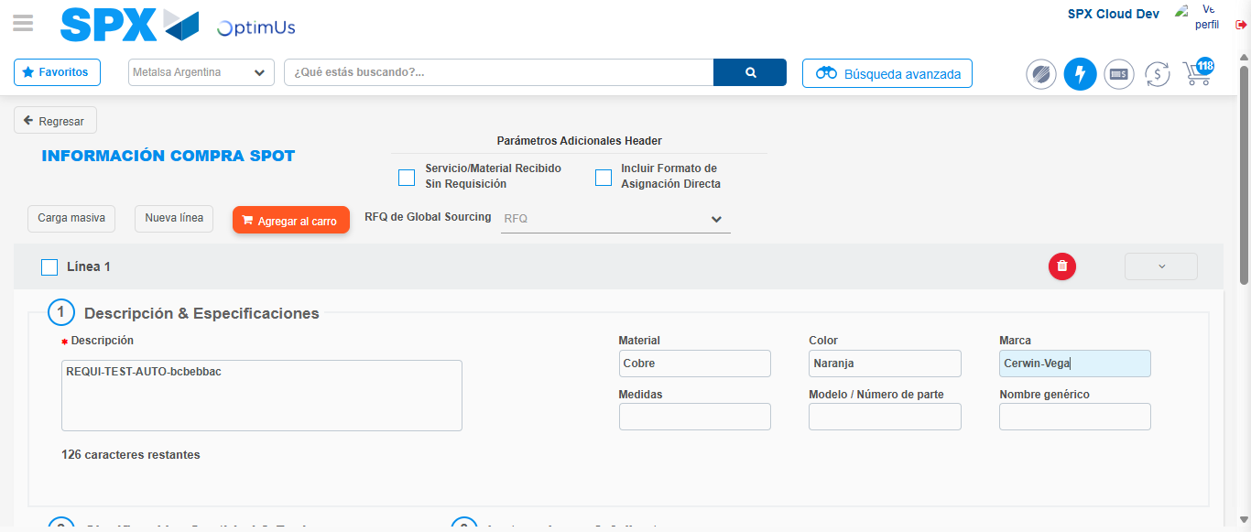Image file-name: QC_Testing-runTestMultipleTimes-nov. 24 2025, 07 32 20 p. m.

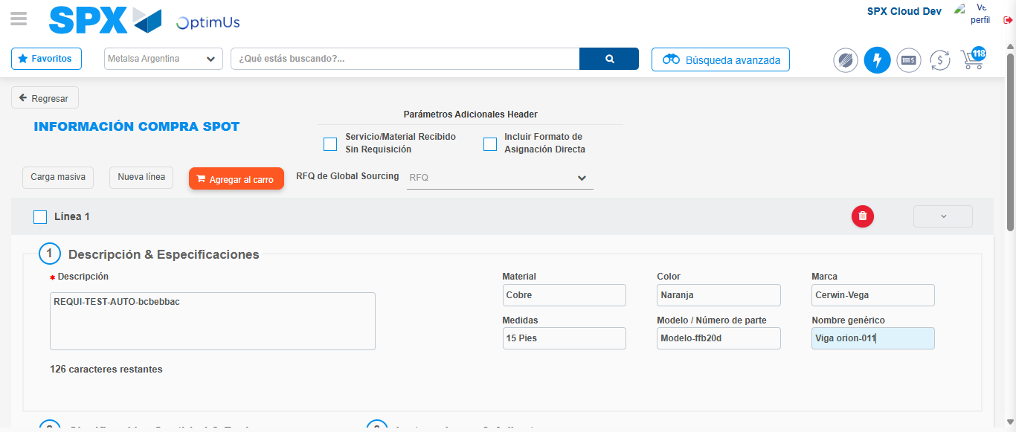Image file-name: QC_Testing-runTestMultipleTimes-nov. 24 2025, 07 32 21 p. m.

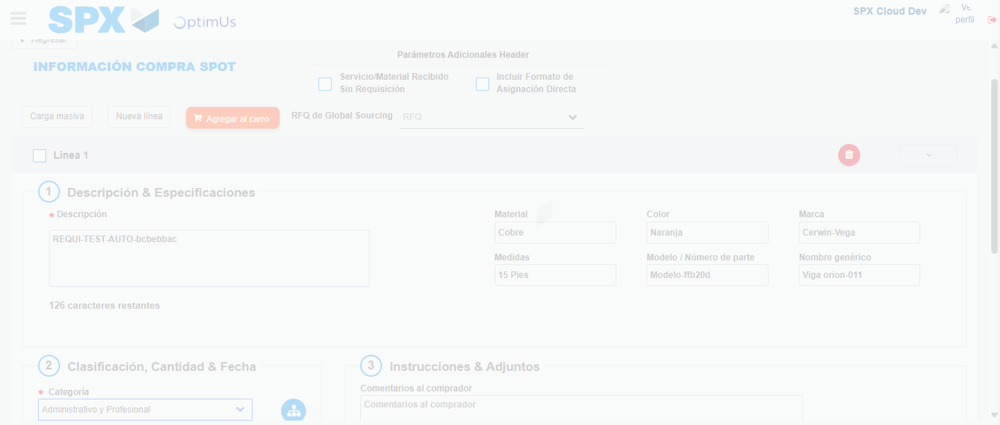Image file-name: QC_Testing-runTestMultipleTimes-nov. 24 2025, 07 32 22 p. m.

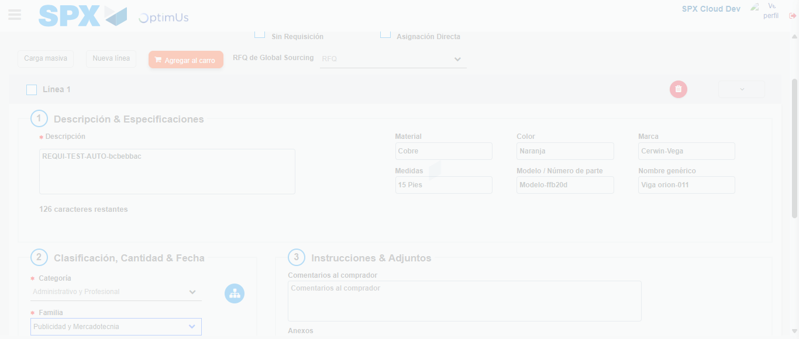Image file-name: QC_Testing-runTestMultipleTimes-nov. 24 2025, 07 32 23 p. m.

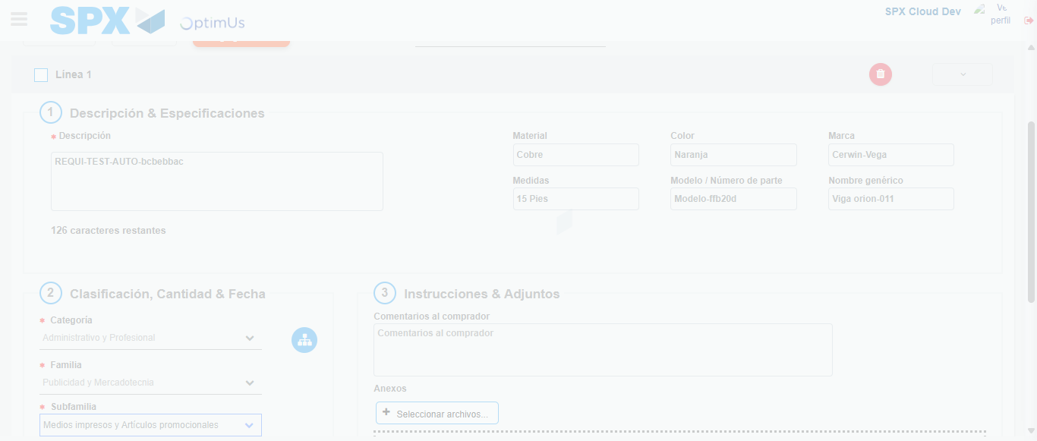Image file-name: QC_Testing-runTestMultipleTimes-nov. 24 2025, 07 32 24 p. m.

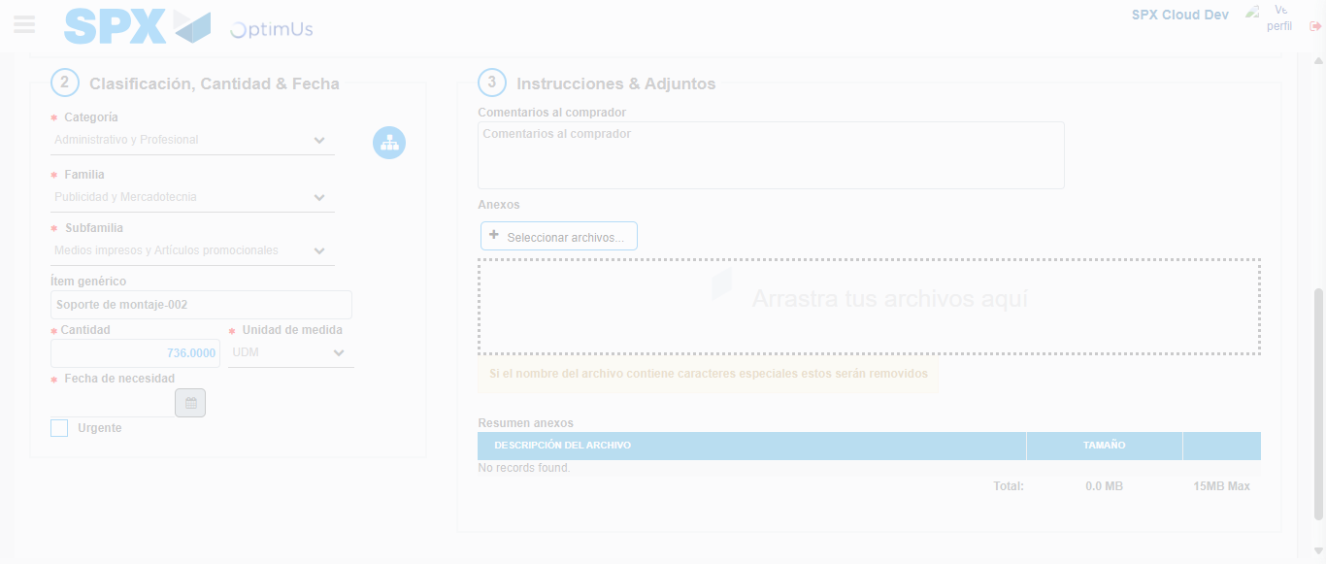Image file-name: QC_Testing-runTestMultipleTimes-nov. 24 2025, 07 32 25 p. m.

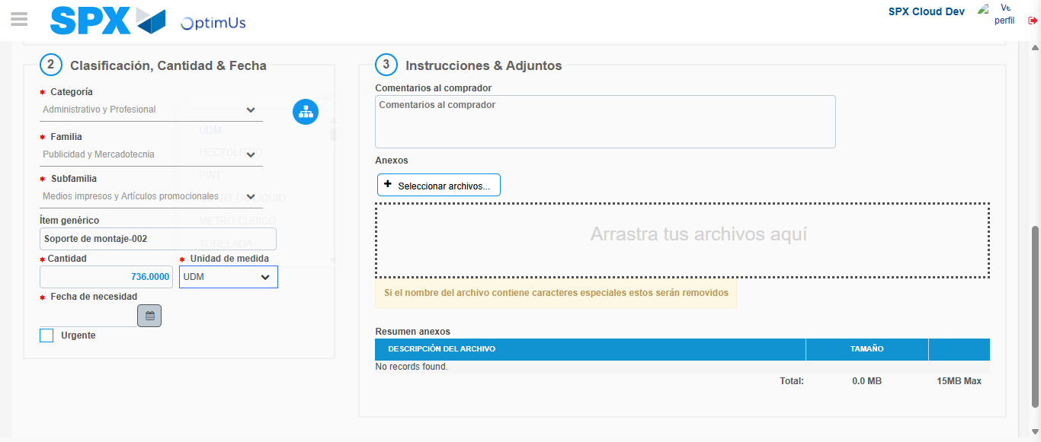Image file-name: QC_Testing-runTestMultipleTimes-nov. 24 2025, 07 32 28 p. m.

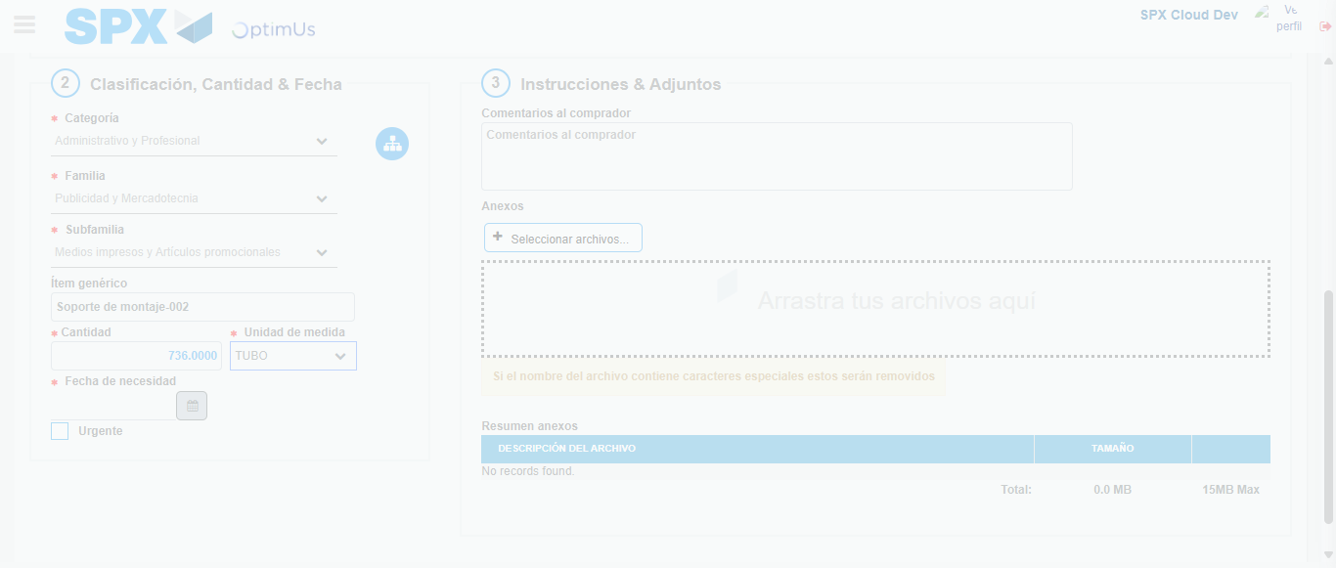Image file-name: QC_Testing-runTestMultipleTimes-nov. 24 2025, 07 32 29 p. m.

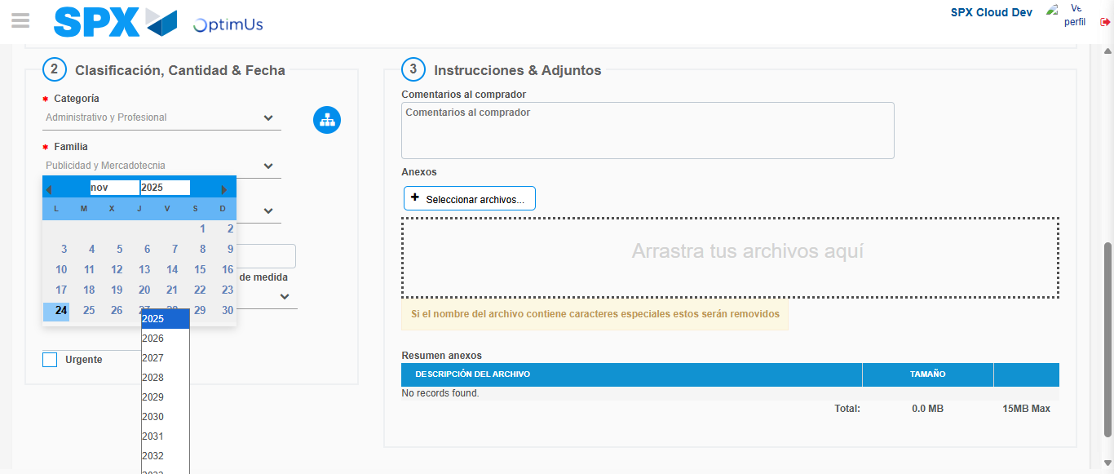Image file-name: QC_Testing-runTestMultipleTimes-nov. 24 2025, 07 32 33 p. m.

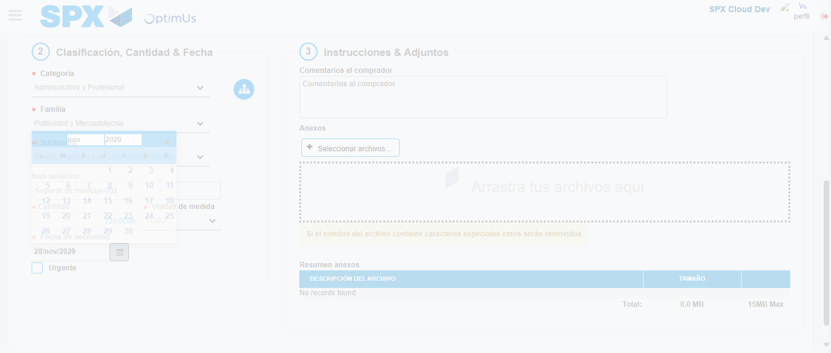Image file-name: QC_Testing-runTestMultipleTimes-nov. 24 2025, 07 32 34 p. m.

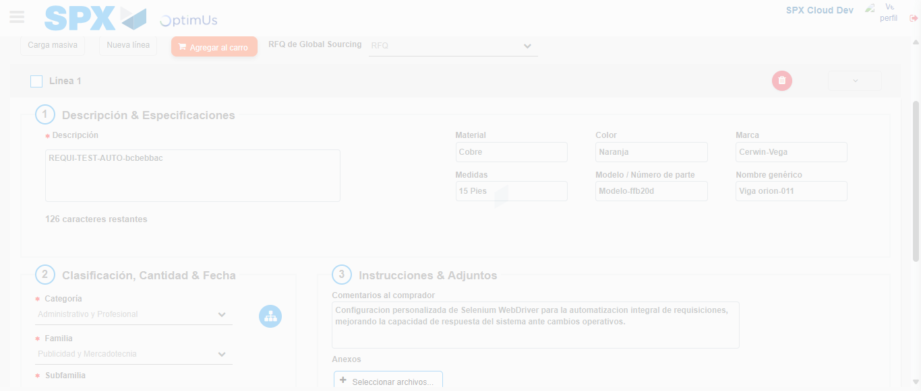Image file-name: QC_Testing-runTestMultipleTimes-nov. 24 2025, 07 32 35 p. m.

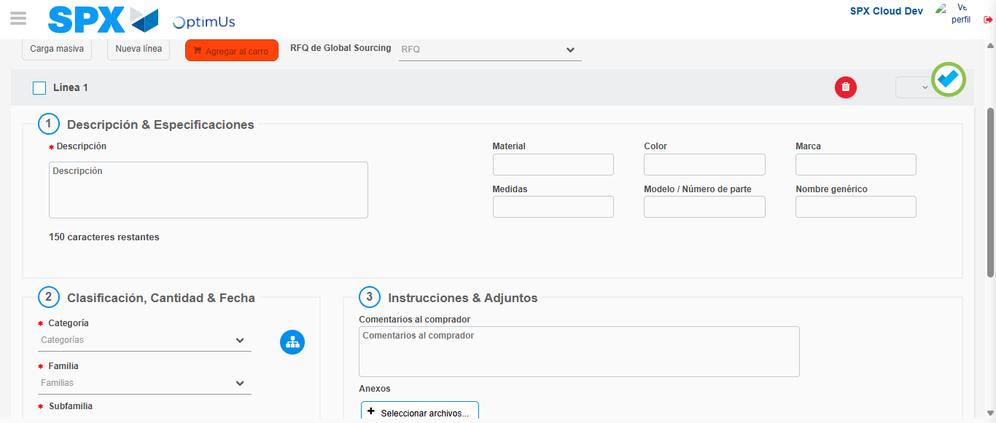Image file-name: QC_Testing-runTestMultipleTimes-nov. 24 2025, 07 32 39 p. m.

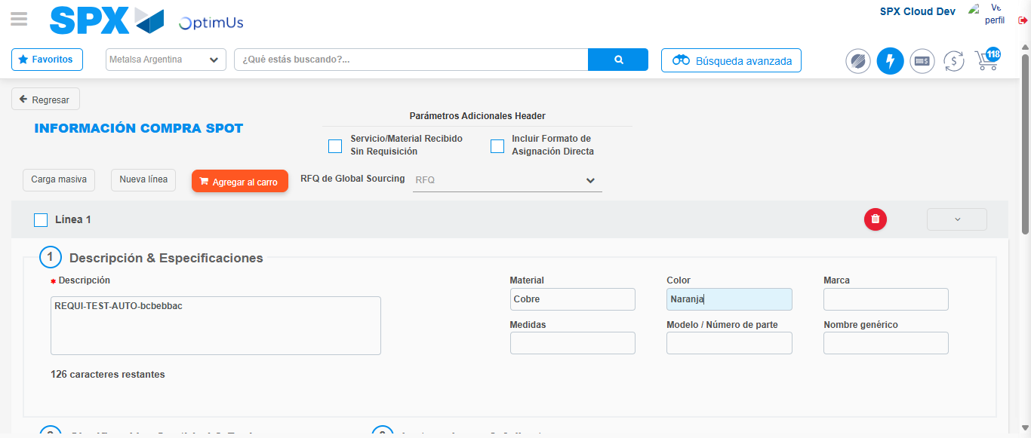Image file-name: QC_Testing-runTestMultipleTimes-nov. 24 2025, 07 33 52 p. m.

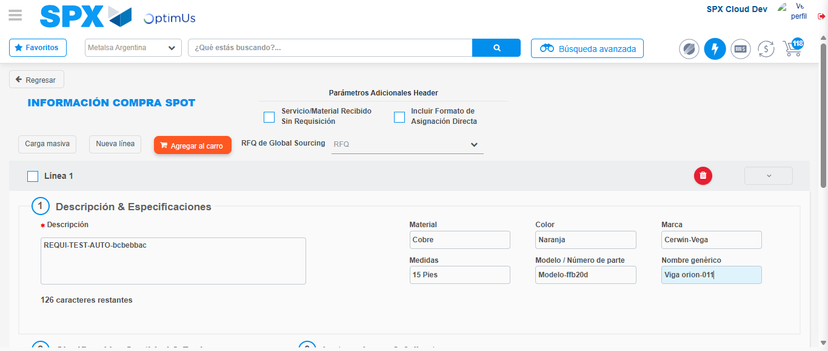Image file-name: QC_Testing-runTestMultipleTimes-nov. 24 2025, 07 33 53 p. m.

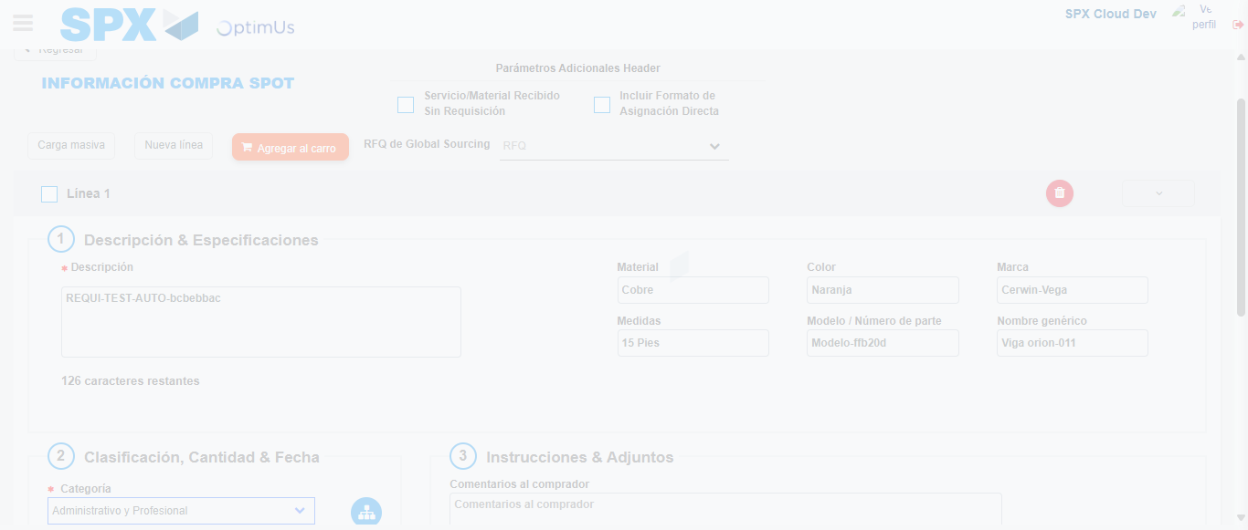Image file-name: QC_Testing-runTestMultipleTimes-nov. 24 2025, 07 33 54 p. m.

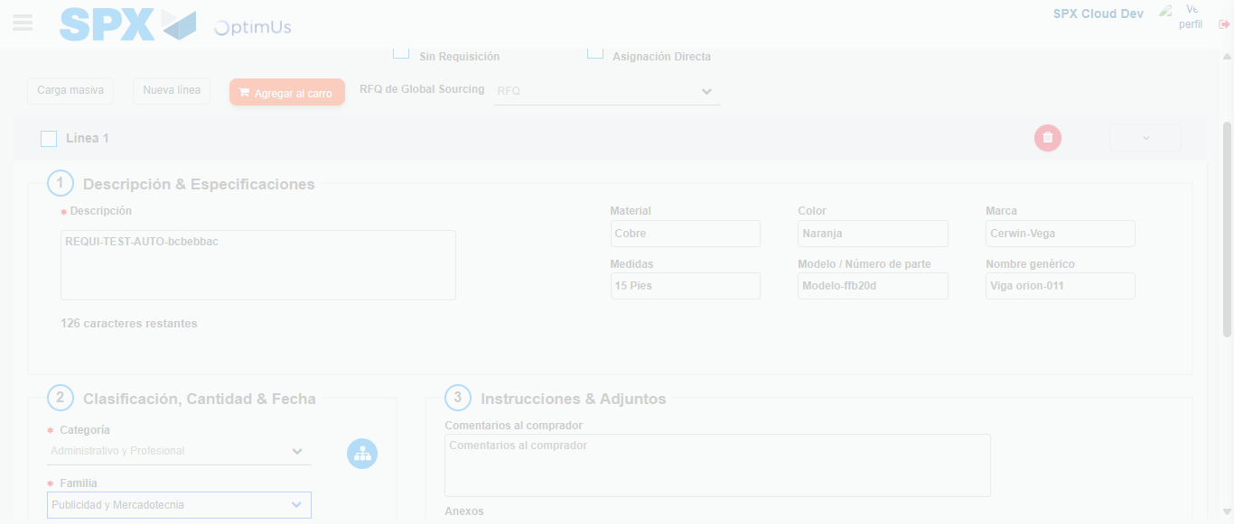Image file-name: QC_Testing-runTestMultipleTimes-nov. 24 2025, 07 33 55 p. m.

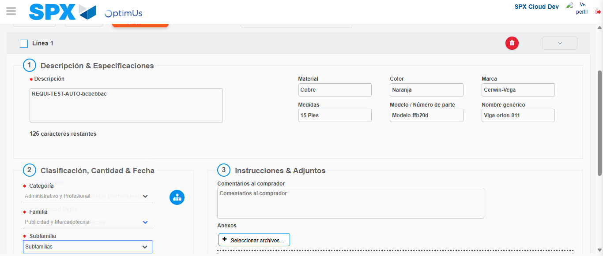Image file-name: QC_Testing-runTestMultipleTimes-nov. 24 2025, 07 33 56 p. m.

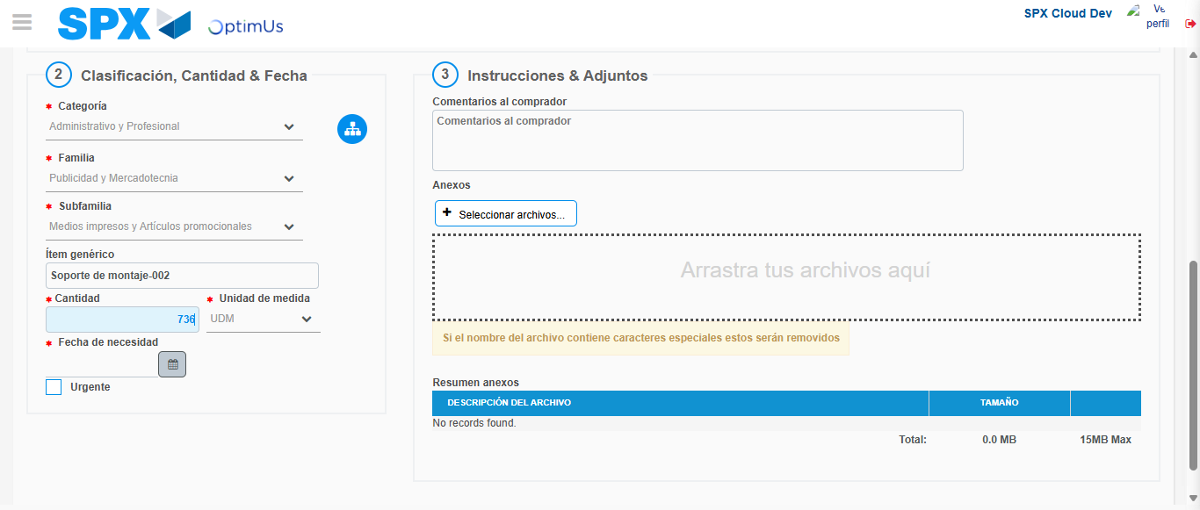Image file-name: QC_Testing-runTestMultipleTimes-nov. 24 2025, 07 33 57 p. m.

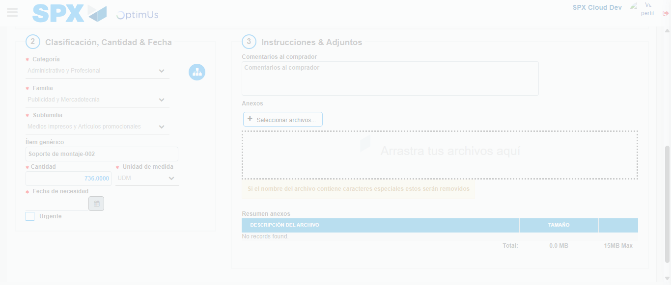Image file-name: QC_Testing-runTestMultipleTimes-nov. 24 2025, 07 33 58 p. m.

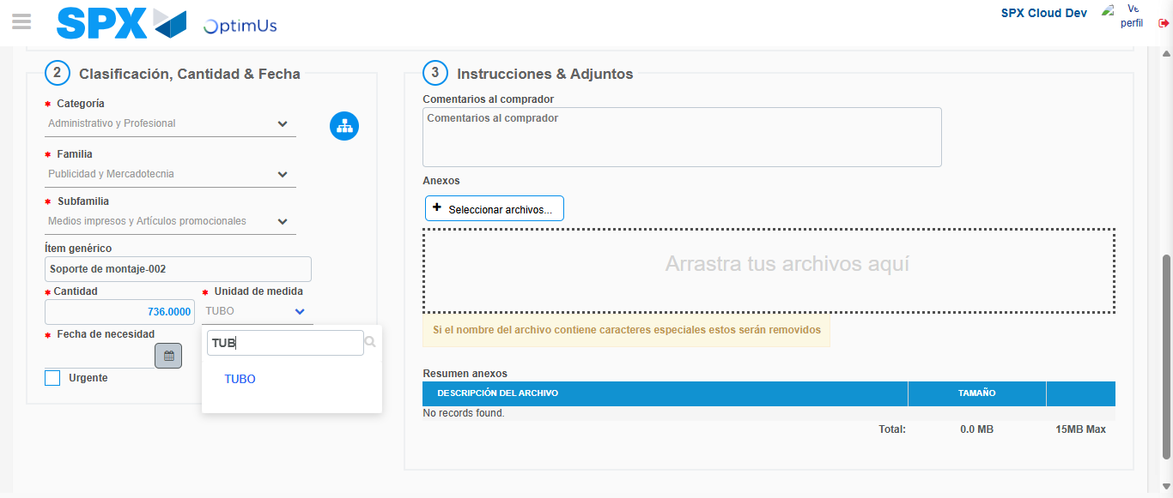Image file-name: QC_Testing-runTestMultipleTimes-nov. 24 2025, 07 34 01 p. m.

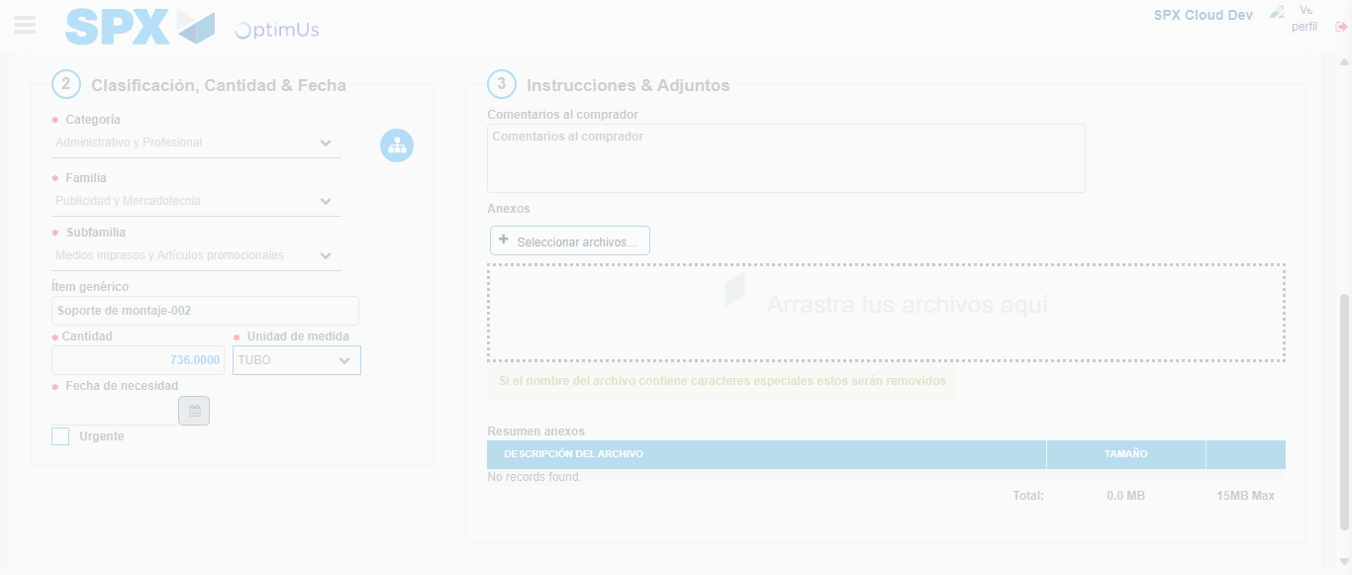Image file-name: QC_Testing-runTestMultipleTimes-nov. 24 2025, 07 34 02 p. m.

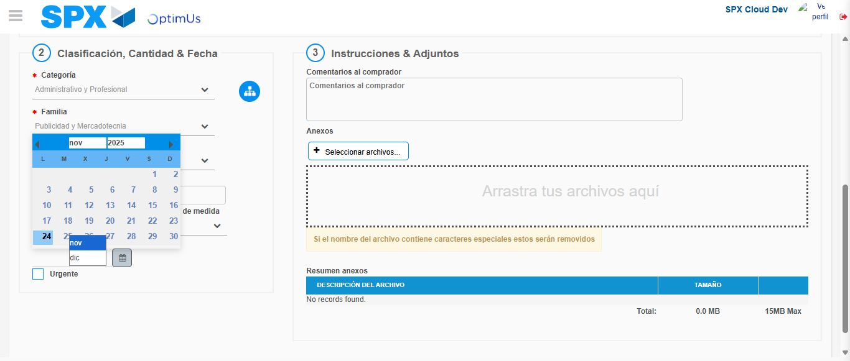Image file-name: QC_Testing-runTestMultipleTimes-nov. 24 2025, 07 34 05 p. m.

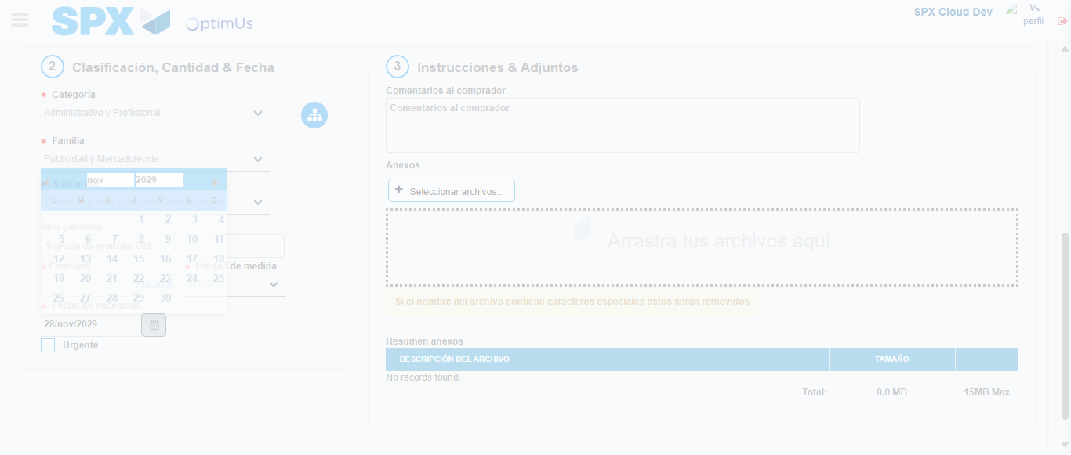Image file-name: QC_Testing-runTestMultipleTimes-nov. 24 2025, 07 34 06 p. m.

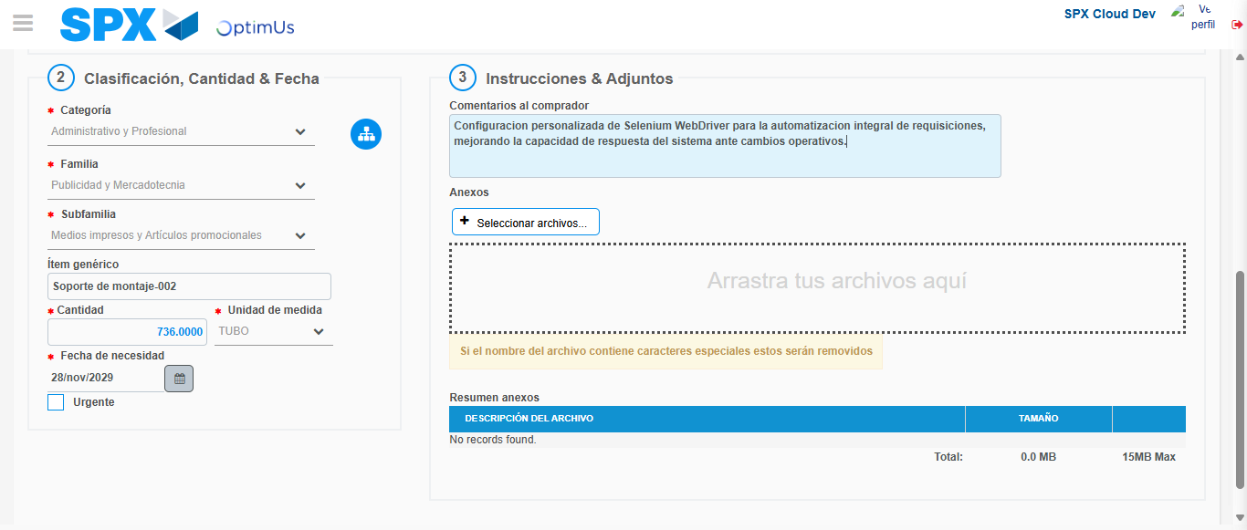Image file-name: QC_Testing-runTestMultipleTimes-nov. 24 2025, 07 34 07 p. m.

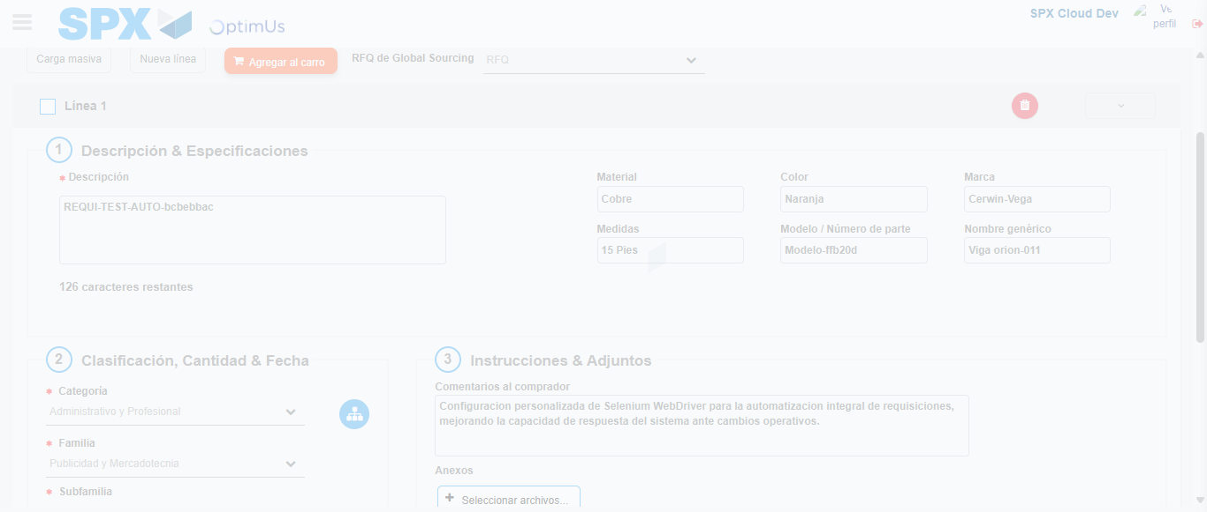Image file-name: QC_Testing-runTestMultipleTimes-nov. 24 2025, 07 34 08 p. m.

Image file-name: QC_Testing-runTestMultipleTimes-nov. 24 2025, 07 34 11 p. m.

Image file-name: QC_Testing-runTestMultipleTimes-nov. 24 2025, 07 34 12 p. m.

Step 4 - Select to Requisition : Requisition Correctly selected
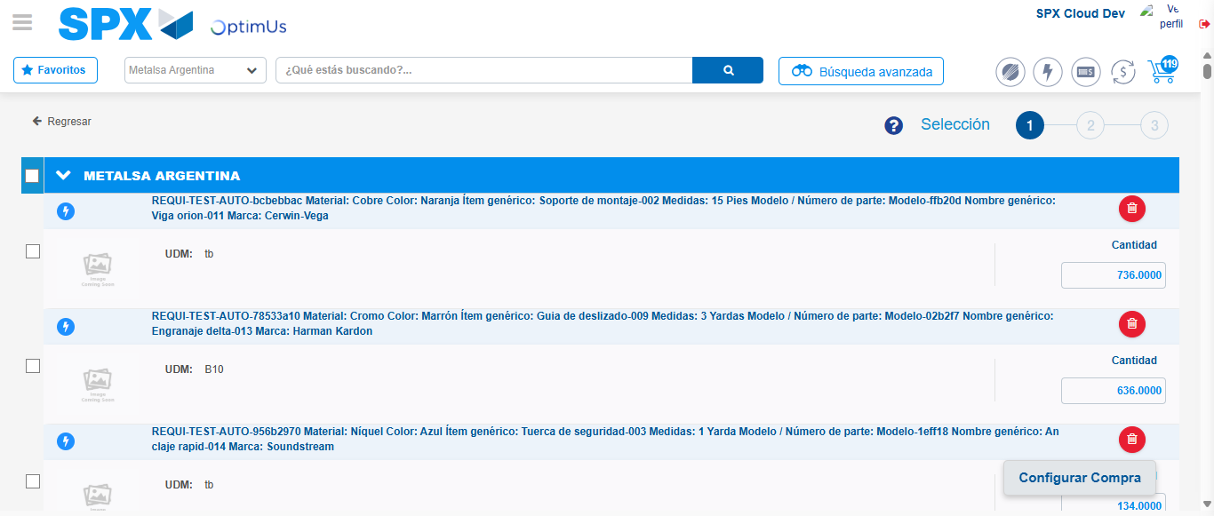Image file-name: QC_Testing-runTestMultipleTimes-nov. 24 2025, 07 32 50 p. m.

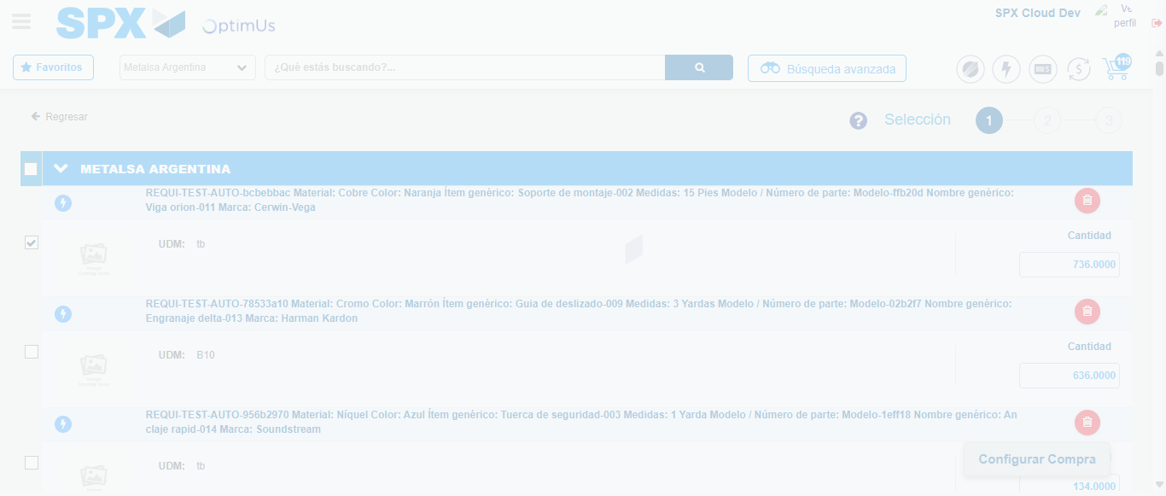Image file-name: QC_Testing-runTestMultipleTimes-nov. 24 2025, 07 32 51 p. m.

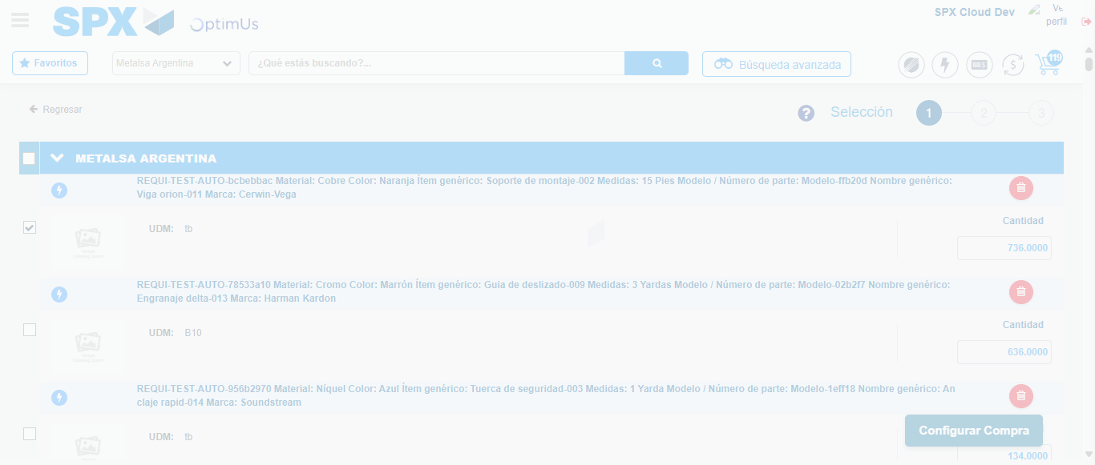Image file-name: QC_Testing-runTestMultipleTimes-nov. 24 2025, 07 32 54 p. m.

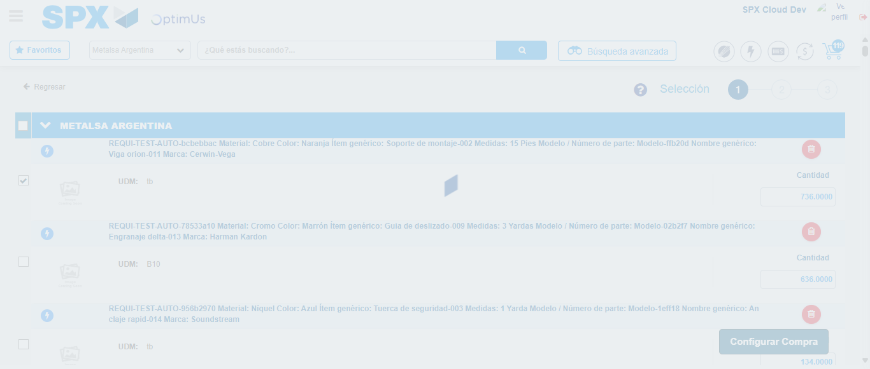Image file-name: QC_Testing-runTestMultipleTimes-nov. 24 2025, 07 32 55 p. m.

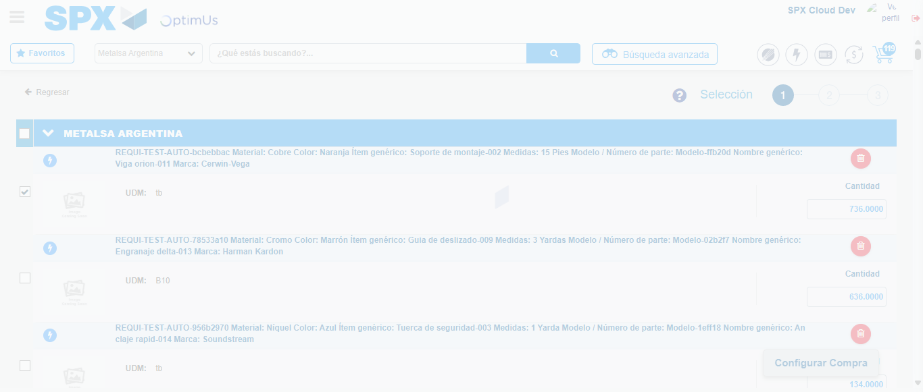Image file-name: QC_Testing-runTestMultipleTimes-nov. 24 2025, 07 34 21 p. m.

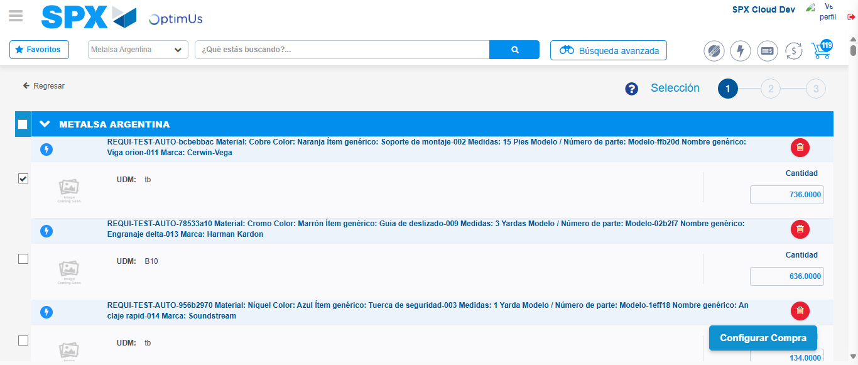Image file-name: QC_Testing-runTestMultipleTimes-nov. 24 2025, 07 34 24 p. m.

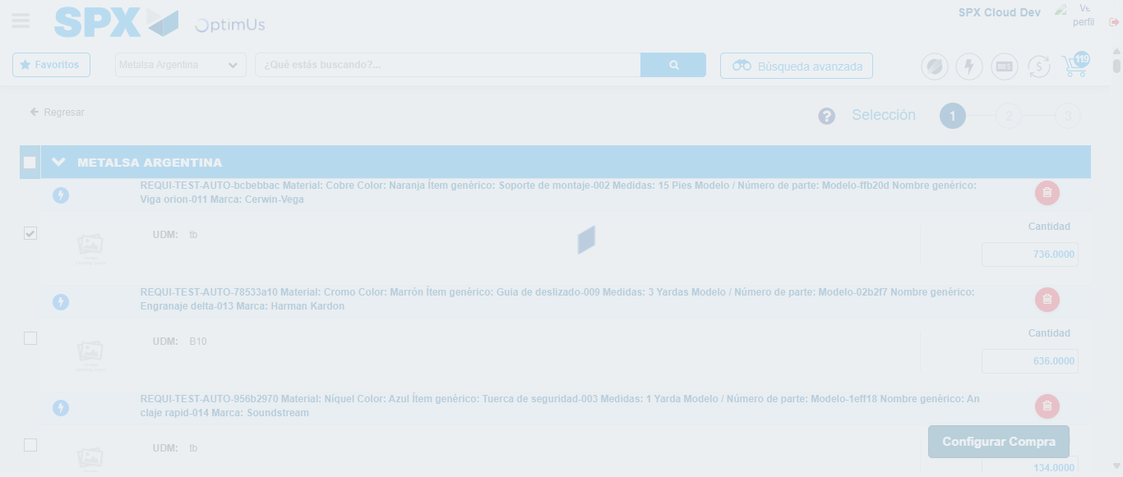Image file-name: QC_Testing-runTestMultipleTimes-nov. 24 2025, 07 34 25 p. m.

Step 5 - Select Type Account For Requisition : Type Account Correctly selected
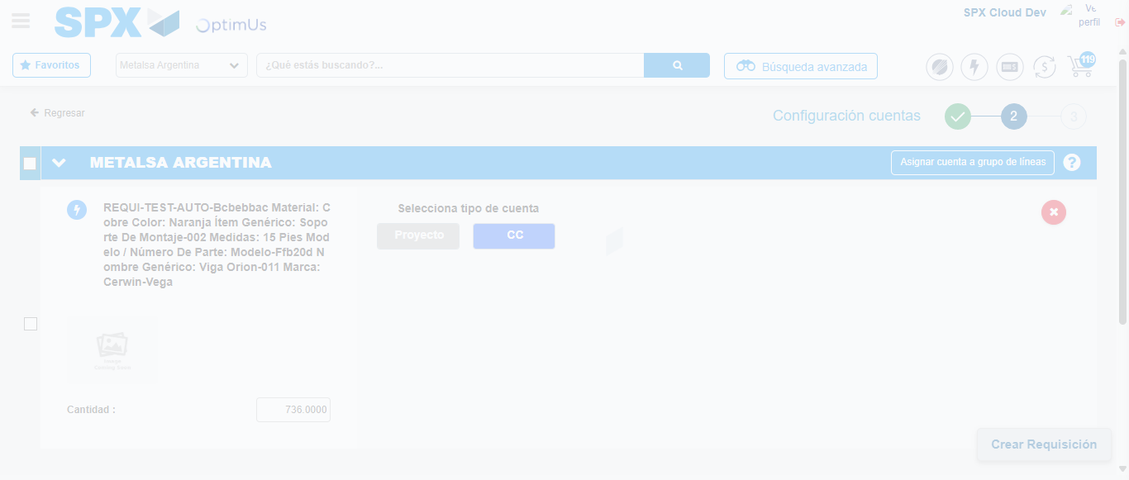Image file-name: QC_Testing-runTestMultipleTimes-nov. 24 2025, 07 32 57 p. m.

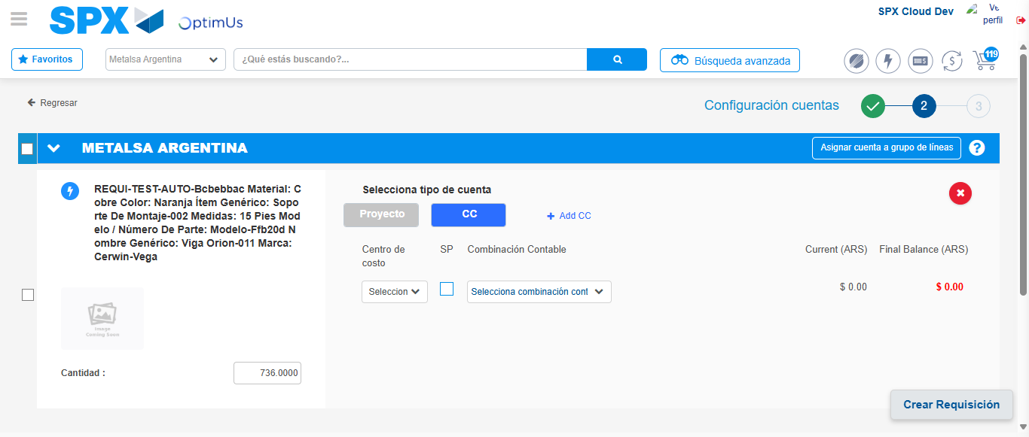Image file-name: QC_Testing-runTestMultipleTimes-nov. 24 2025, 07 33 00 p. m.

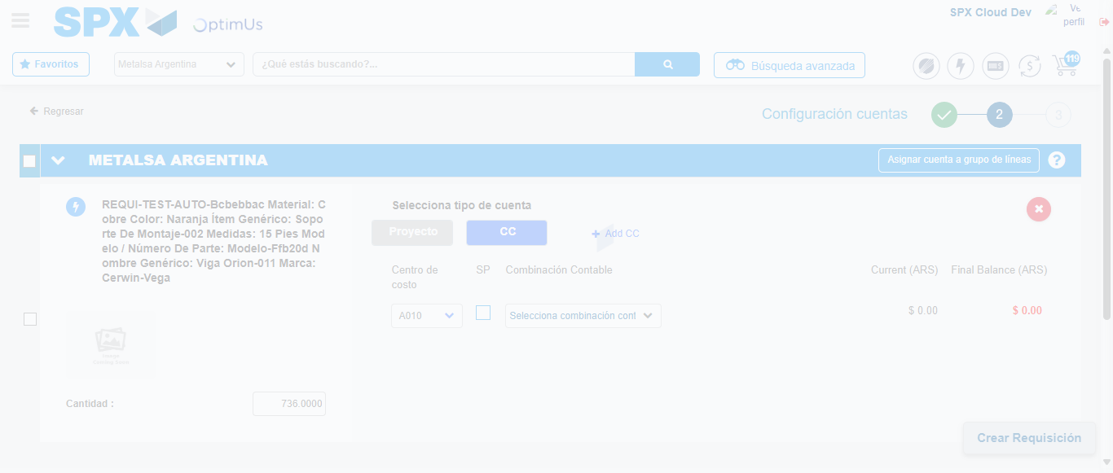Image file-name: QC_Testing-runTestMultipleTimes-nov. 24 2025, 07 33 04 p. m.

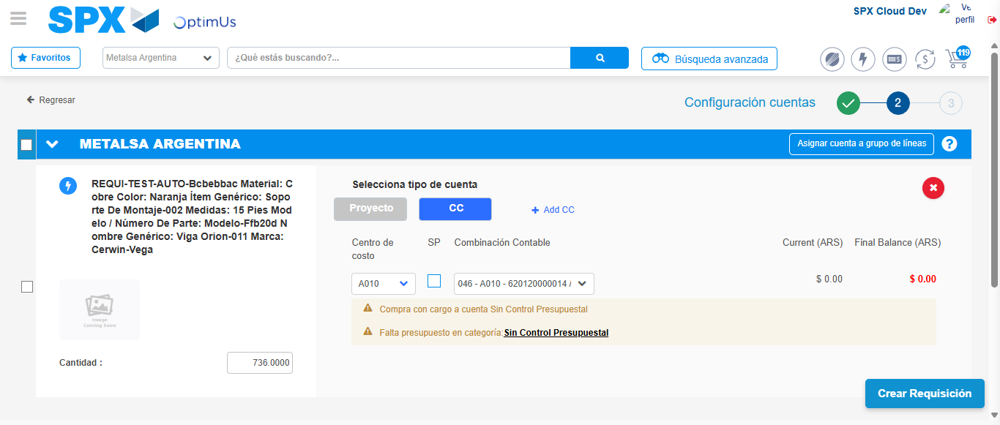Image file-name: QC_Testing-runTestMultipleTimes-nov. 24 2025, 07 33 07 p. m.

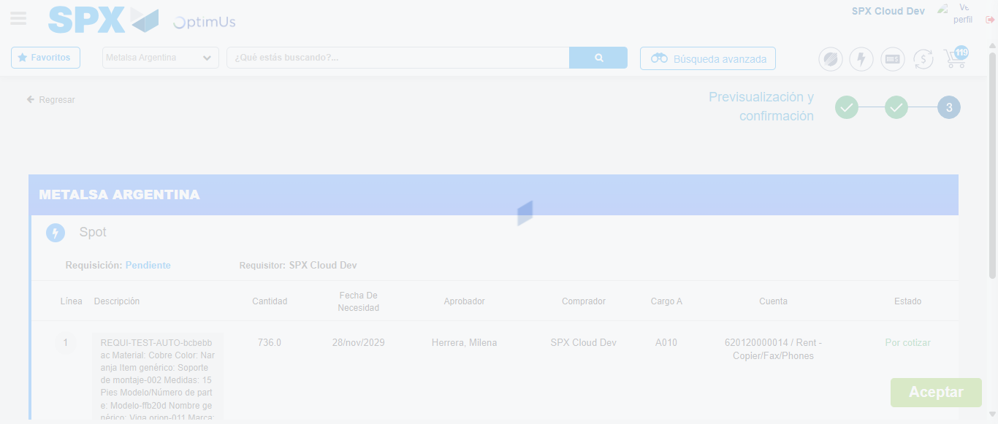Image file-name: QC_Testing-runTestMultipleTimes-nov. 24 2025, 07 33 08 p. m.

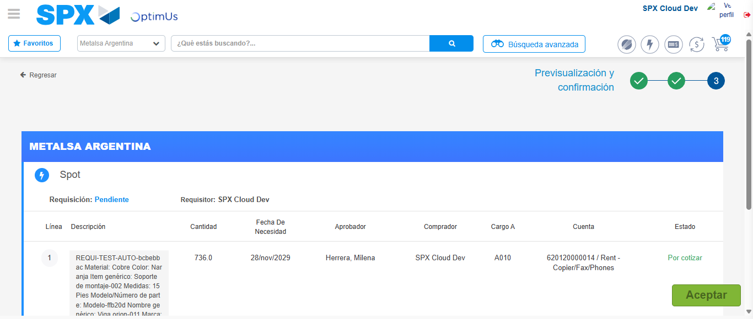Image file-name: QC_Testing-runTestMultipleTimes-nov. 24 2025, 07 33 11 p. m.

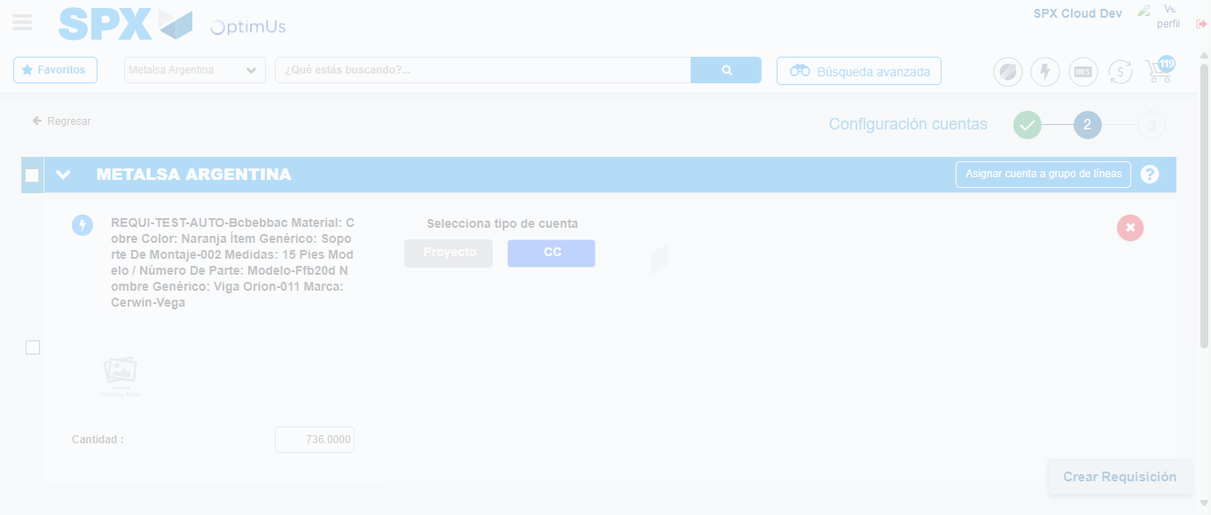Image file-name: QC_Testing-runTestMultipleTimes-nov. 24 2025, 07 34 28 p. m.

Image file-name: QC_Testing-runTestMultipleTimes-nov. 24 2025, 07 34 31 p. m.

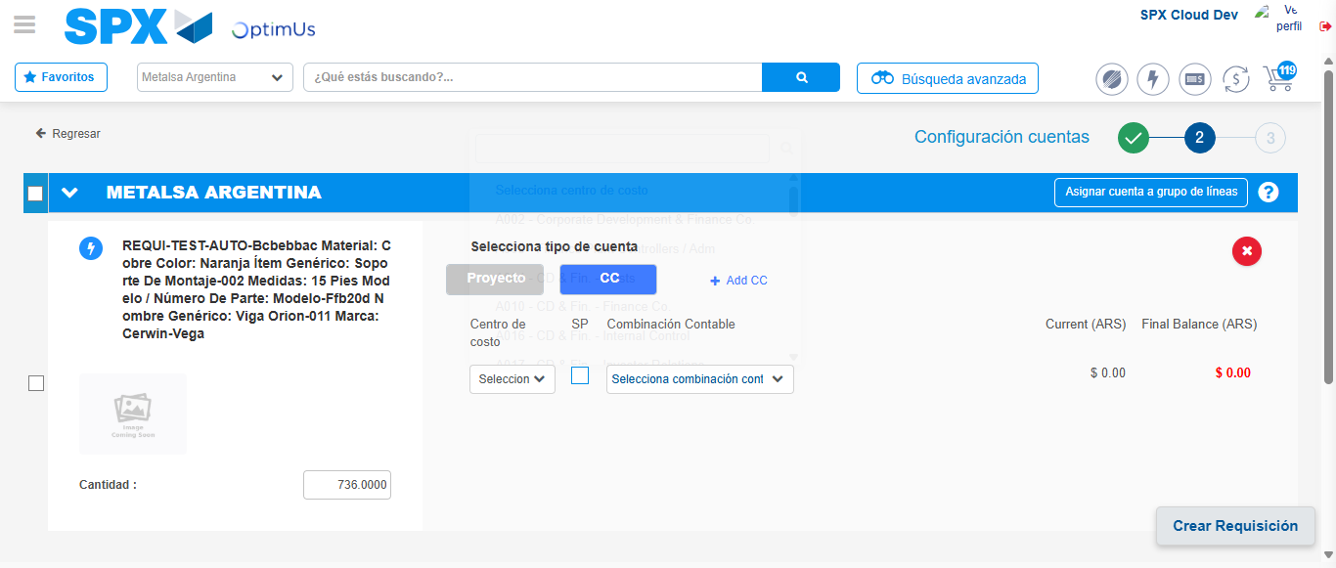Image file-name: QC_Testing-runTestMultipleTimes-nov. 24 2025, 07 34 34 p. m.

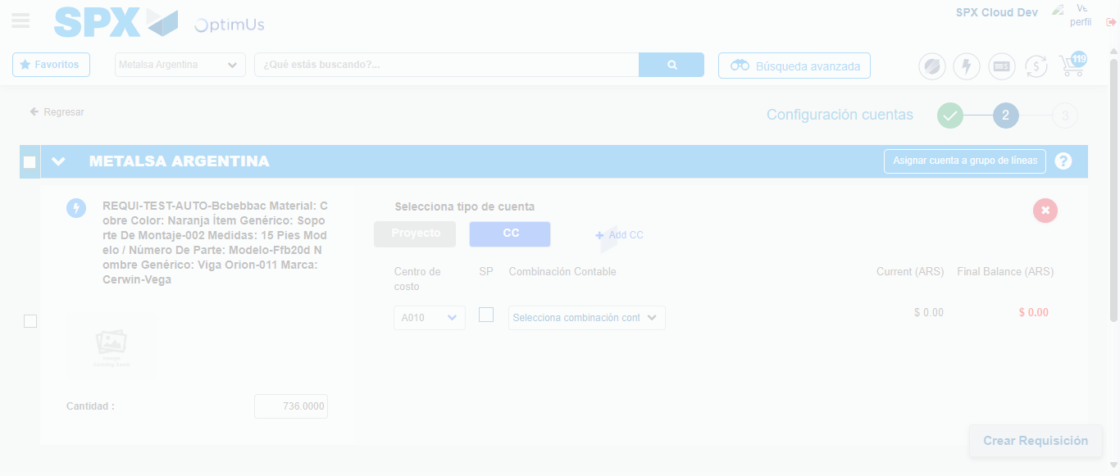Image file-name: QC_Testing-runTestMultipleTimes-nov. 24 2025, 07 34 35 p. m.

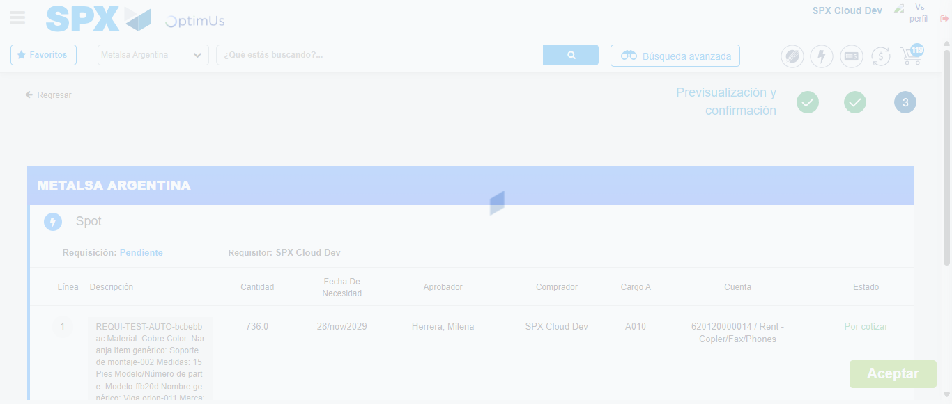Image file-name: QC_Testing-runTestMultipleTimes-nov. 24 2025, 07 34 38 p. m.

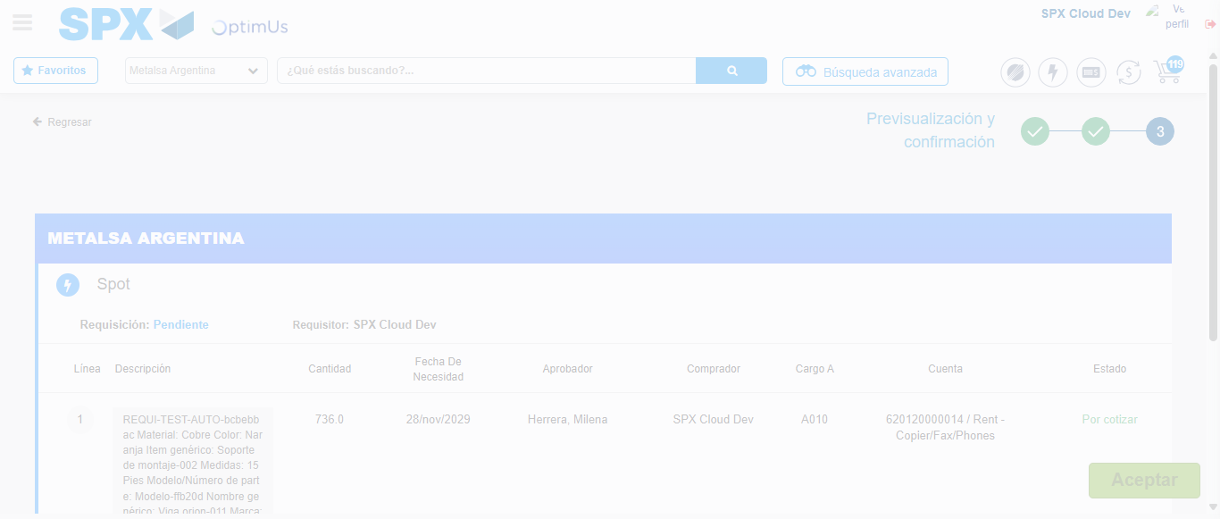Image file-name: QC_Testing-runTestMultipleTimes-nov. 24 2025, 07 34 42 p. m.

Step 6 - Accept to Requisition : Requisition Accepted
Image file-name: QC_Testing-runTestMultipleTimes-nov. 24 2025, 07 33 12 p. m.

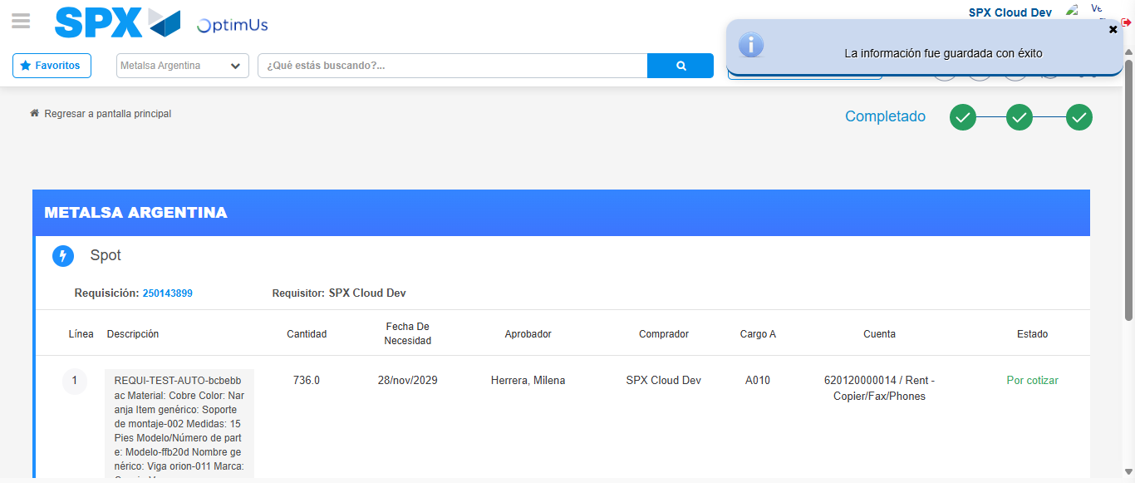Image file-name: QC_Testing-runTestMultipleTimes-nov. 24 2025, 07 33 15 p. m.

Image file-name: QC_Testing-runTestMultipleTimes-nov. 24 2025, 07 34 42 p. m.

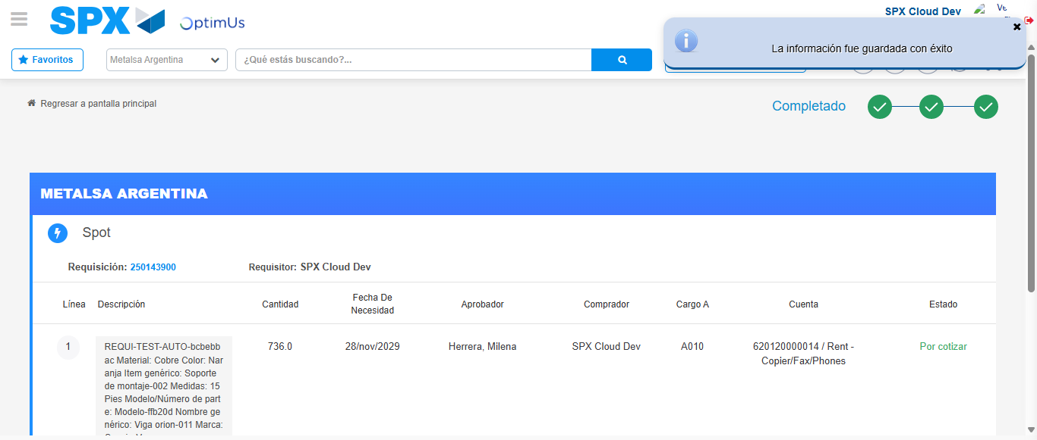Image file-name: QC_Testing-runTestMultipleTimes-nov. 24 2025, 07 34 46 p. m.

